|  |  |  |  |
| --- | --- | --- | --- |
| Task |  | Hours | Status |
| Edit metadata and content | |  |  |
|  | Add metadata for all page | 10 | done |
|  | Edit and optimize content | 20 | 70% |
| Edit home page “Need custom T-shirts” content | | 2 | Done |
| Add chat box | | 2 | Done |
| Edit social URL link | | 2 | Done |
| Fix error upload limit size | | 0 | Done |
| Add more print price over 1500 pieces | | 4 | Done |
| Add more shipping box number | | 4 | Done |

**Another task:**

**Project 5**

|  |  |  |
| --- | --- | --- |
| Task |  | Status |
| New home page | |  |
|  | Top text is misspelled. On header. Please show me the misspelled text | done |
|  | Change Colors |
|  | Change Content text to all same fonts to match |
|  | Adding New links on the bottom |
|  | Add new description and video |
|  | Is it possible to have the slide screen have Actual Text over the image? And not being part of the image? With a Button created to be on top of the image?  Currently we can add caption text for image. But it only the plain text and only show on left of image. |
| MANUALLY assigning job | |  |
|  | Able to EDIT sizes | done |
|  | Able to edit prices | done |
|  | Able to add in CUSTOM product | 16 |
|  | Adding customer first name in schedule list | done |
|  | Go directly into order page after add new | done |
| APPAREL GARMENTS | |  |
|  | Able to edit garment apparel list | 8 |
| SCHEDULE | |  |
|  | Highlighting current jobs SYMBOLS and different colors | 16 |
| SWATCH COLORS | |  |
|  | Able to click ONCE to high light | done |
|  | Change “Available color” text |
| COLOR ISSUES: | |  |
|  | Show color of ink color | processing |
|  | Show name of color they picked. | done |
|  | Add custom PMS color | processing |
|  | CREATING PROOF ON BACK END or having option of ADDING proof. | 8 |
| DESIGN STUDIO edits | |  |
|  | ALWAYS allow Free transform. Change DOTS into Arrows. | processing |
| Remove back ground color | |  |
|  | Able to remove background color automatically When uploading any type of file. | Cannot |
| Editing Manually deposit | |  |
|  | Edit to new layout | 6 |
|  | show option of CHECK, CASH, OR CREDIT | 4 |
| HOME PAGE MOBILE LAYOUT | |  |
|  | Edit new home mobile layout | 4 |
|  | Change Our Services layout | 8 |
| Each service page | |  |
|  | Edit layout to new layout | done |
| SAVE/EMAIL: | |  |
|  | Button: Send design to email | 4 |
|  | Share+send email to user email | 4 |
| **Total** | | **138** |

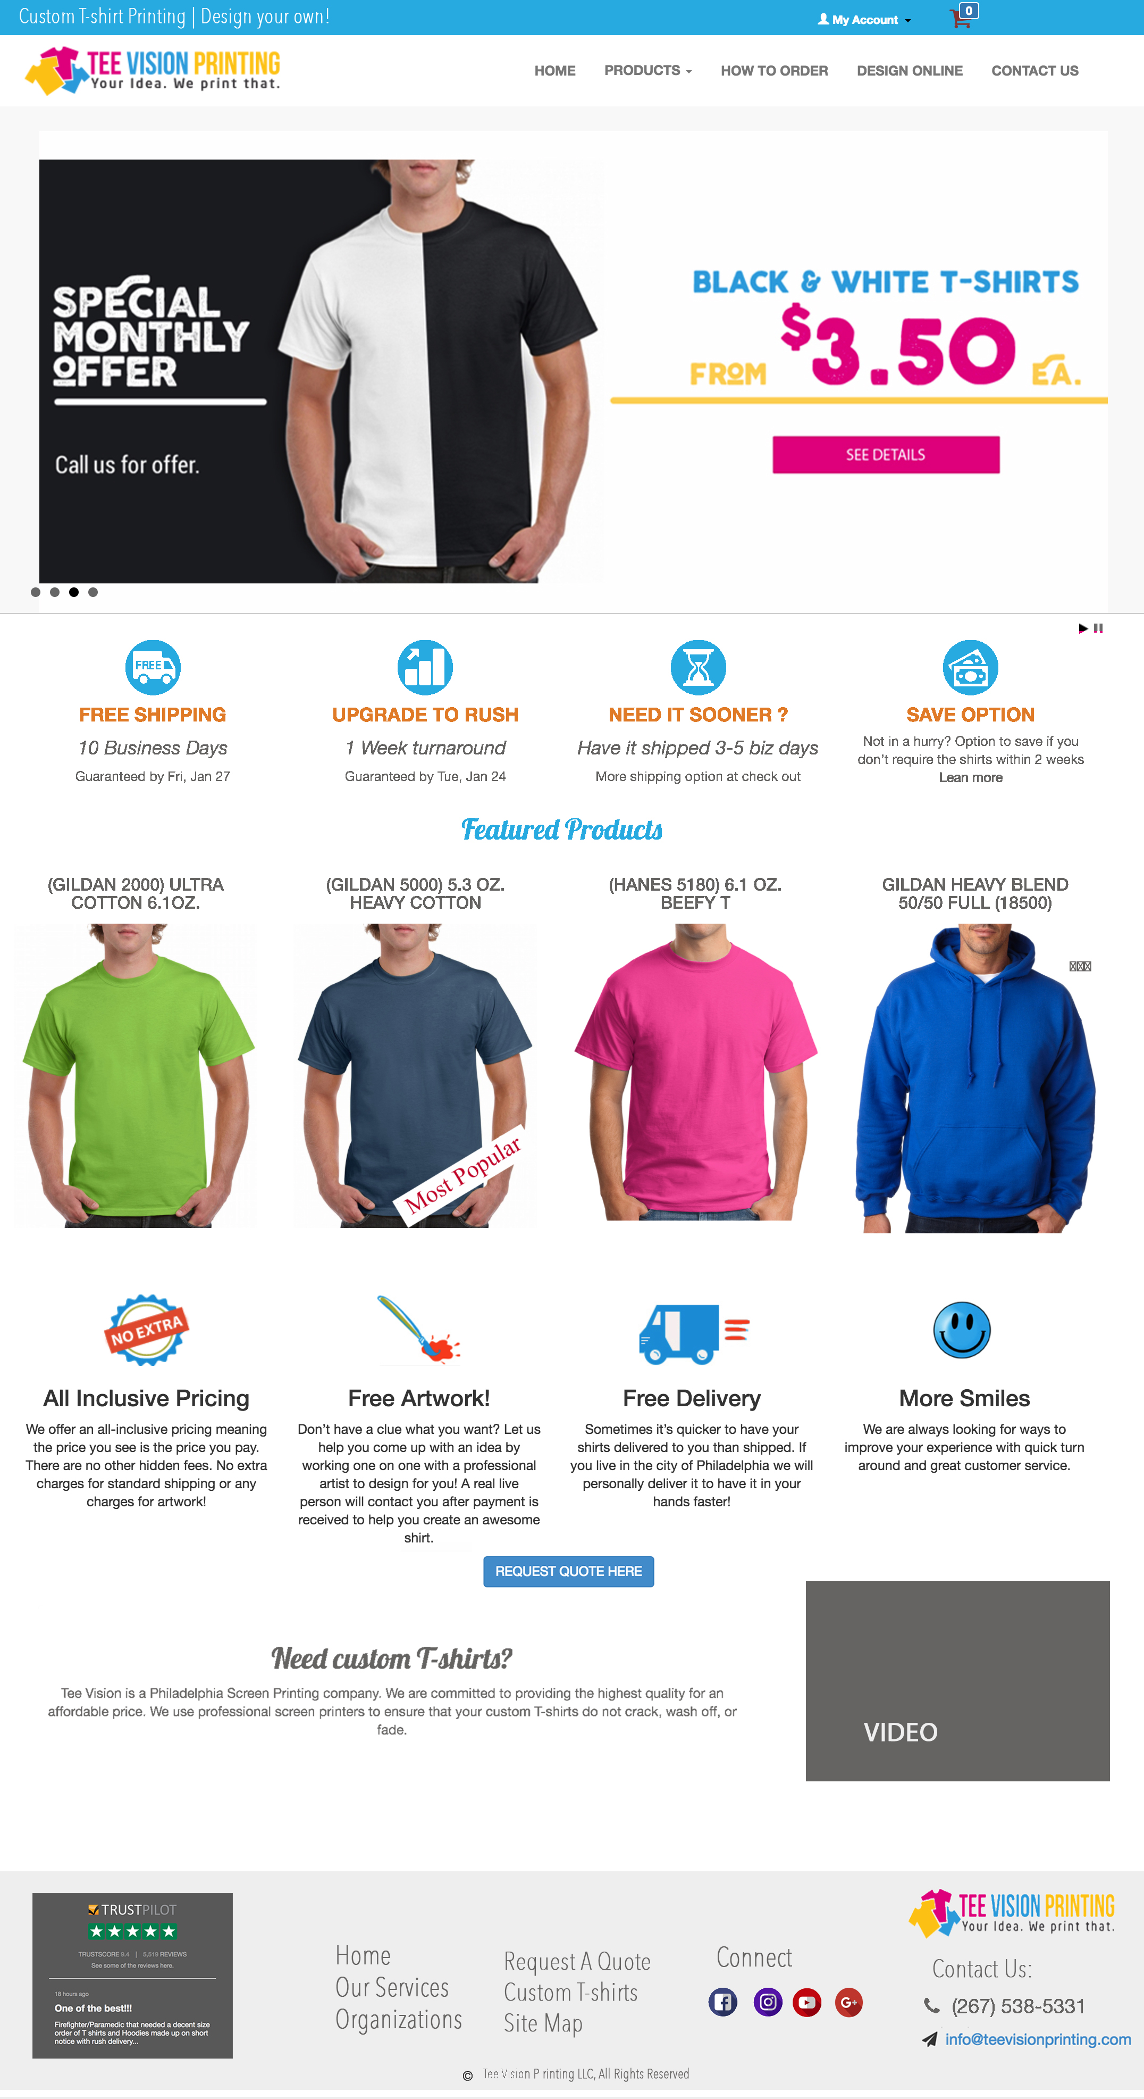

1. Top text is misspelled. On header.
2. Change Colors
3. Change Content text to all same fonts to match
4. Adding New links on the bottom:
5. We are creating a video and adding in later
6. Is it possible to have the slide screen have Actual Text over the image? And not being part of the image? With a Button created to be on top of the image?

1) Remove back ground color

Able to remove background color automatically When uploading any type of file.

The image should be transparent and able to change the color as well from what they uploaded.

2) SWATCH COLORS

Able to click ONCE to high light. (in mobile view, user currently has to click twice to select. Please change it to the first click)

Change Available color: Preview available colors: ( Black ) *** Show color name when selected.

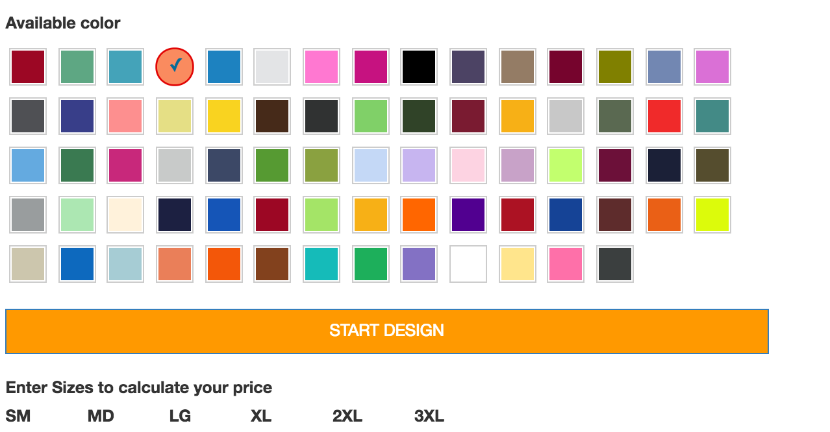

3) COLOR ISSUES:

Show color of ink color

Show name of color they picked.

Add custom PMS color:

(also when they upload image to show what colors they picked)

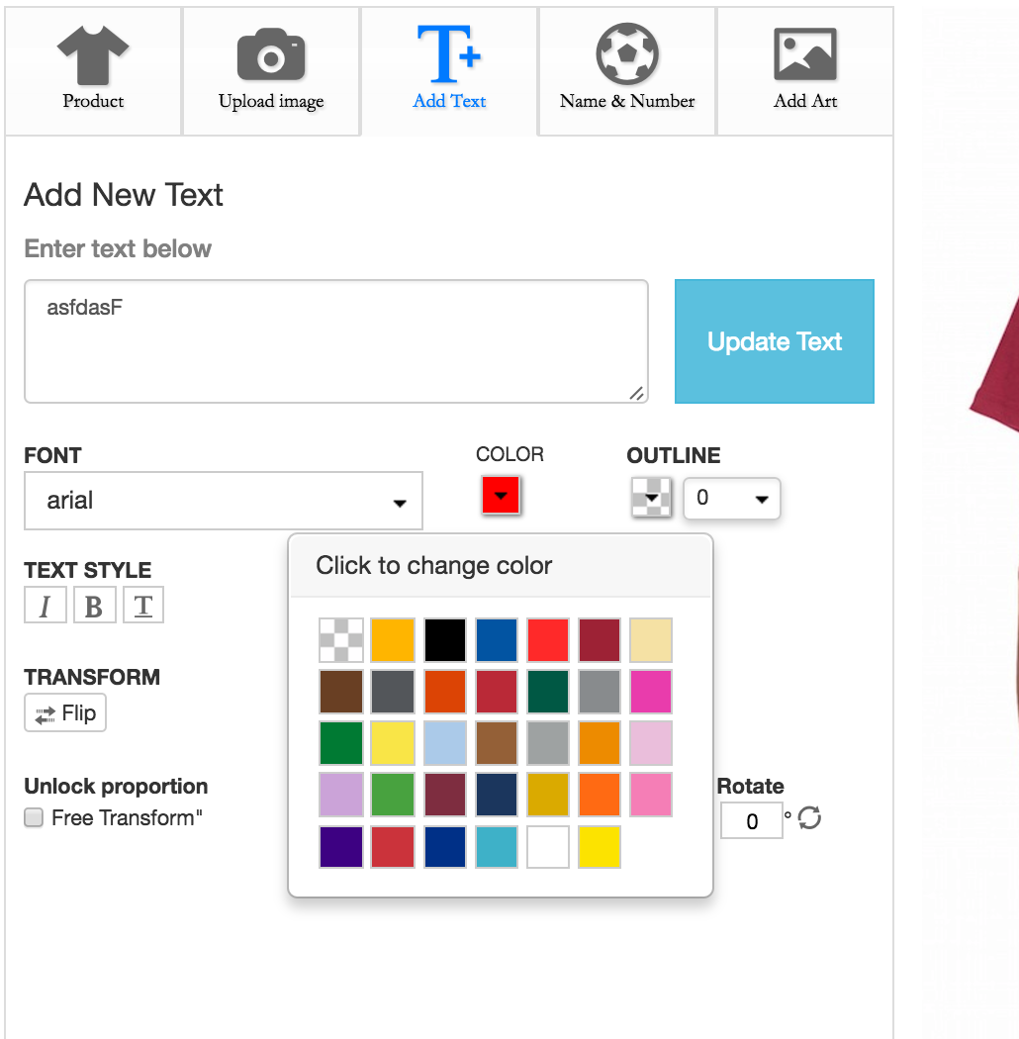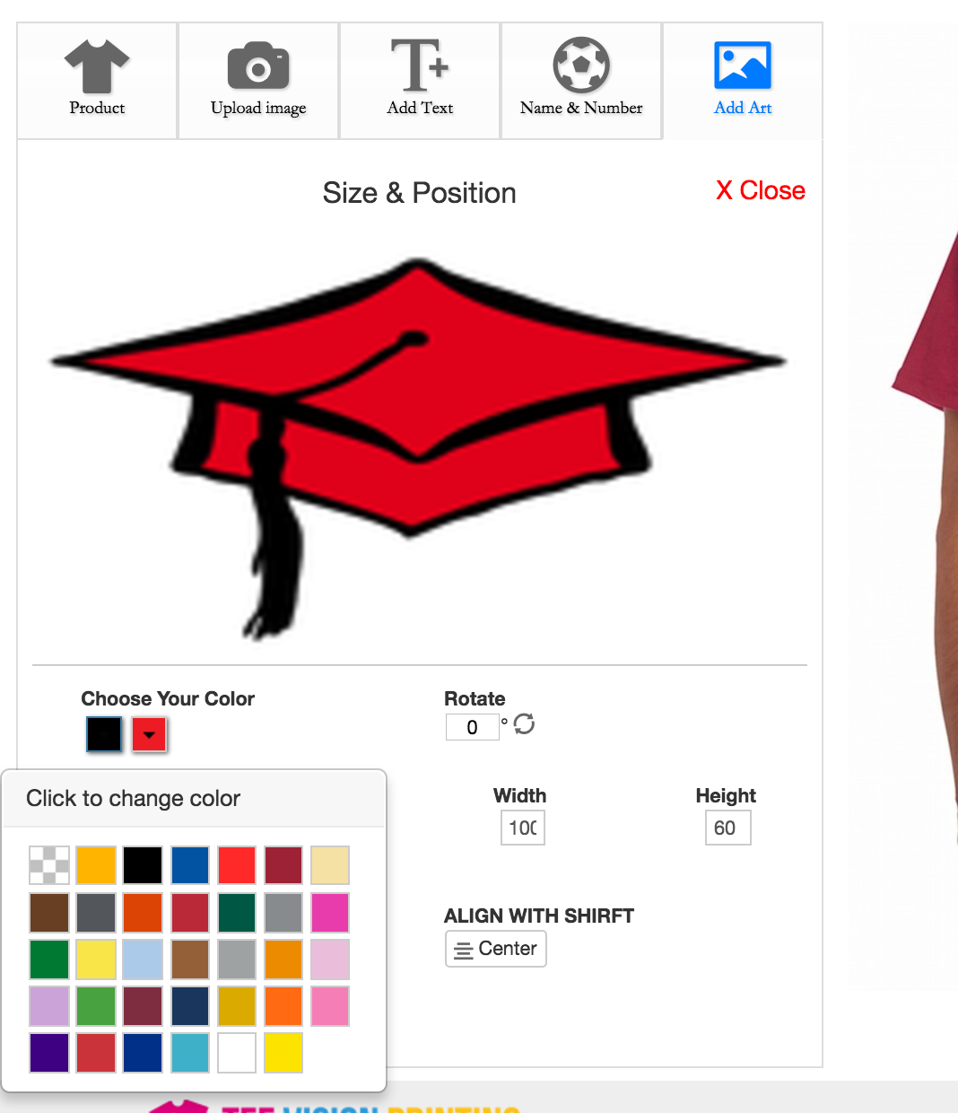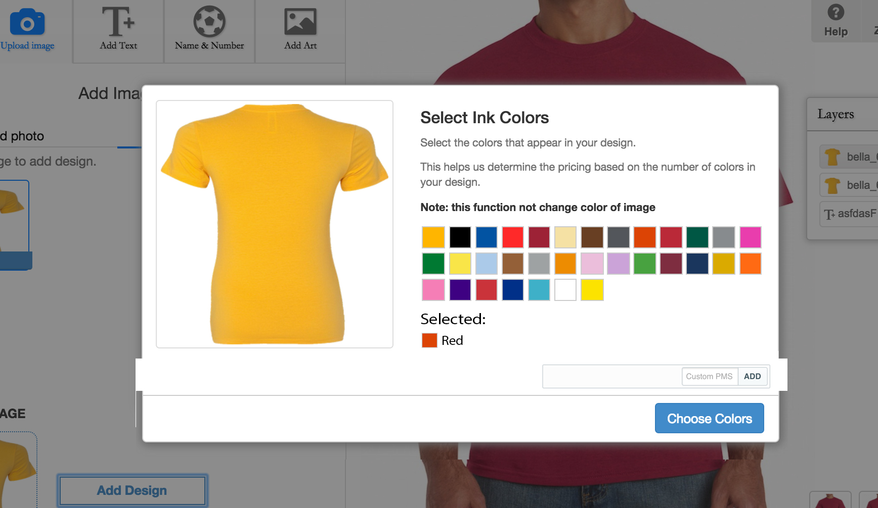

4) DESIGN STUDIO edits

Unlocking button removed and able to expand on screen. ALWAYS allow Free transform. Change DOTS into Arrows.

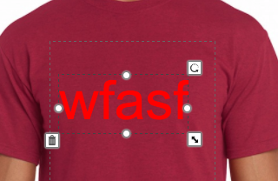

5) SAVE/EMAIL:

When saving design: However I do not want the Link there. I want a button to say “Send design to my email!

: 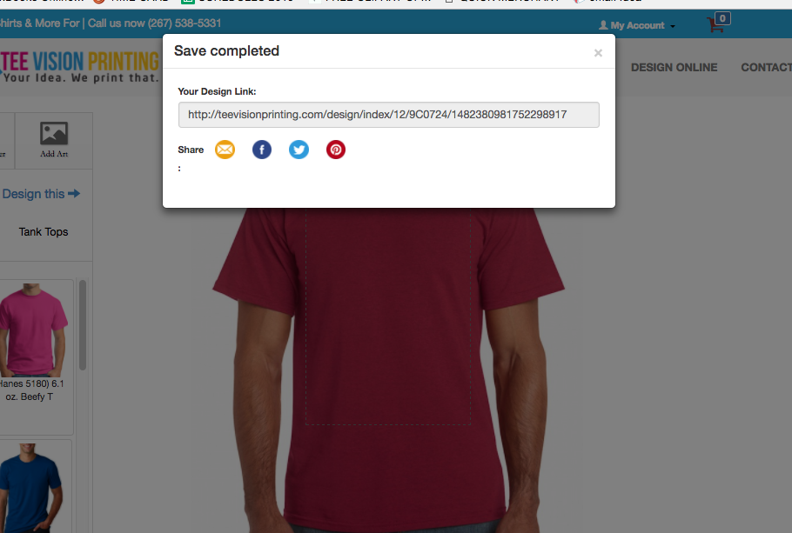

6) HOME PAGE MOBILE LAYOUT

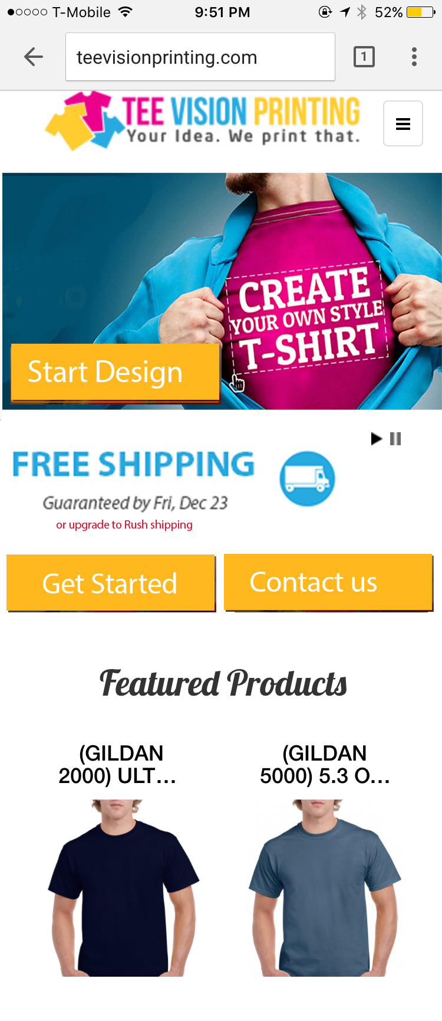

7) Our Services layout:

<http://teevisionprinting.com/services>

Change to

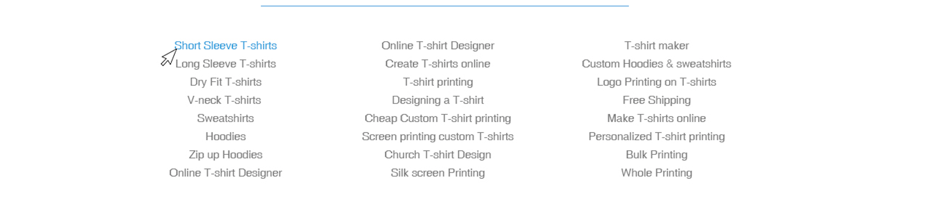

Change Each service page to: (ignore the create custom unique t-shrits to the right)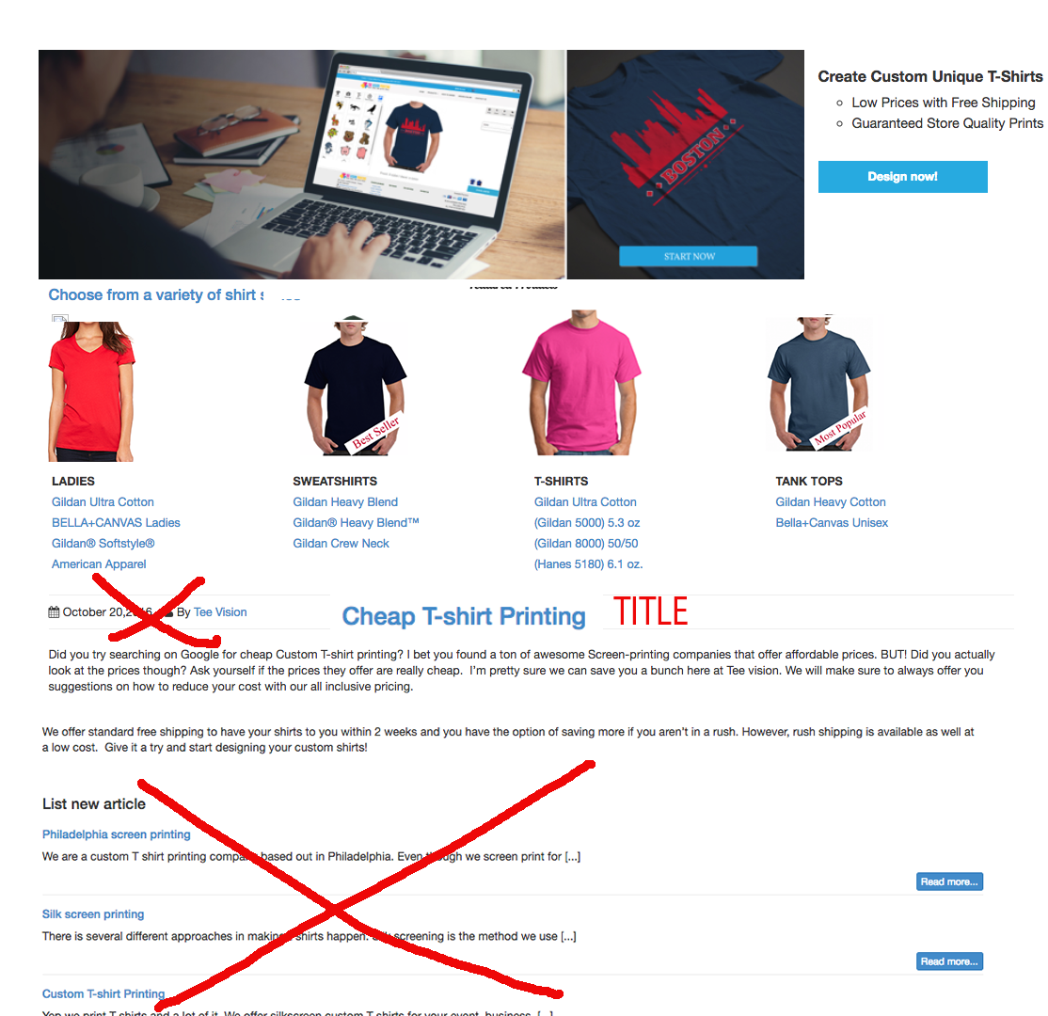

Cities Pages layout:

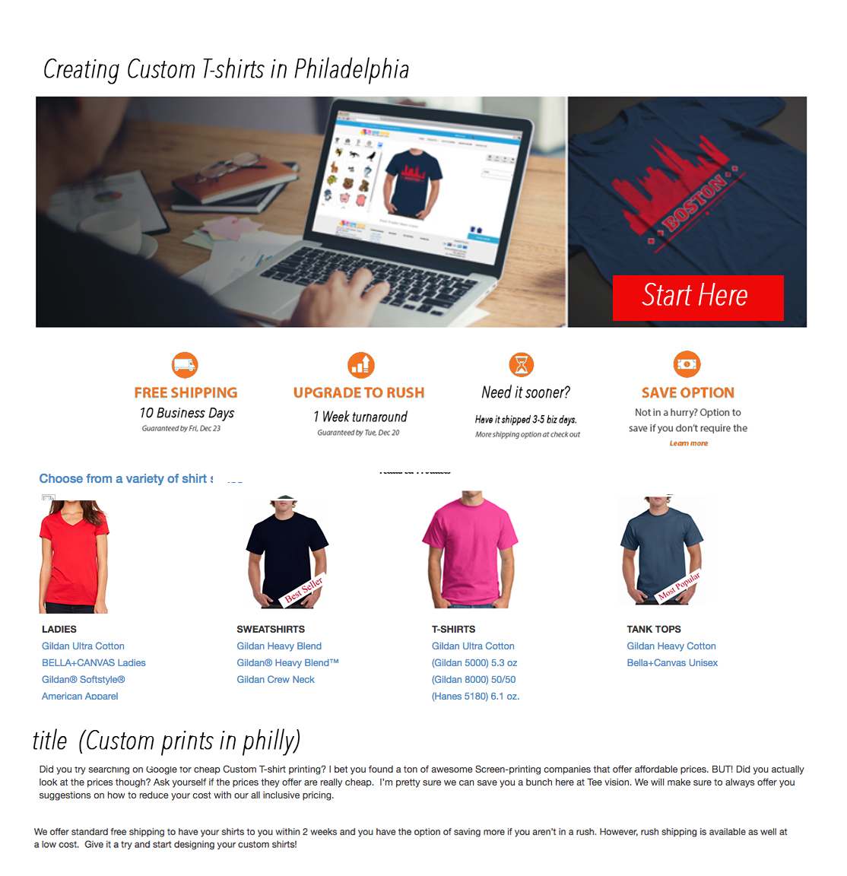

- MANUALLY assigning job

1) Able to EDIT sizes

2) Able to edit prices 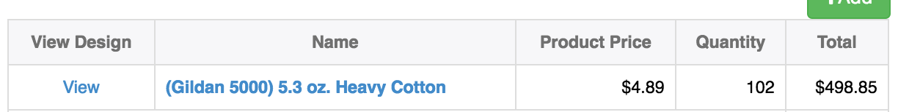

3) Able to add in CUSTOM product (custom not from list of products)

* enters product name, PRICES, and quantity (NO CALCULATED PRICES REQUORED, completely manually input)
* 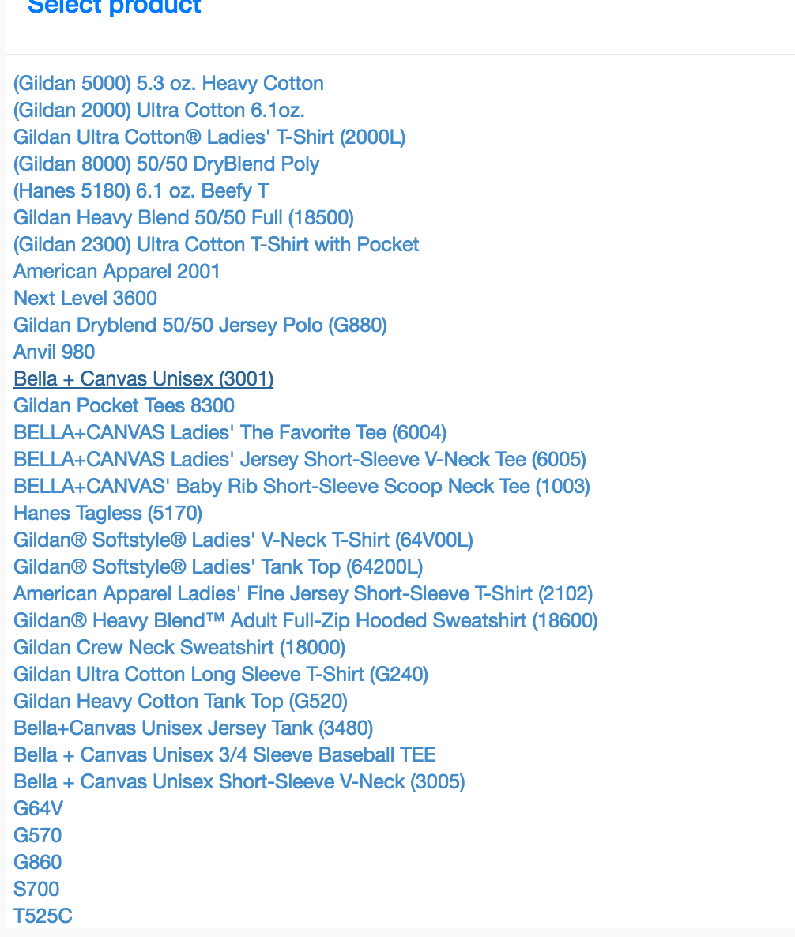

4) Adding customer first name in schedule list

5) When adding new order after finish it goes directly into order page so edits can be made of that order.

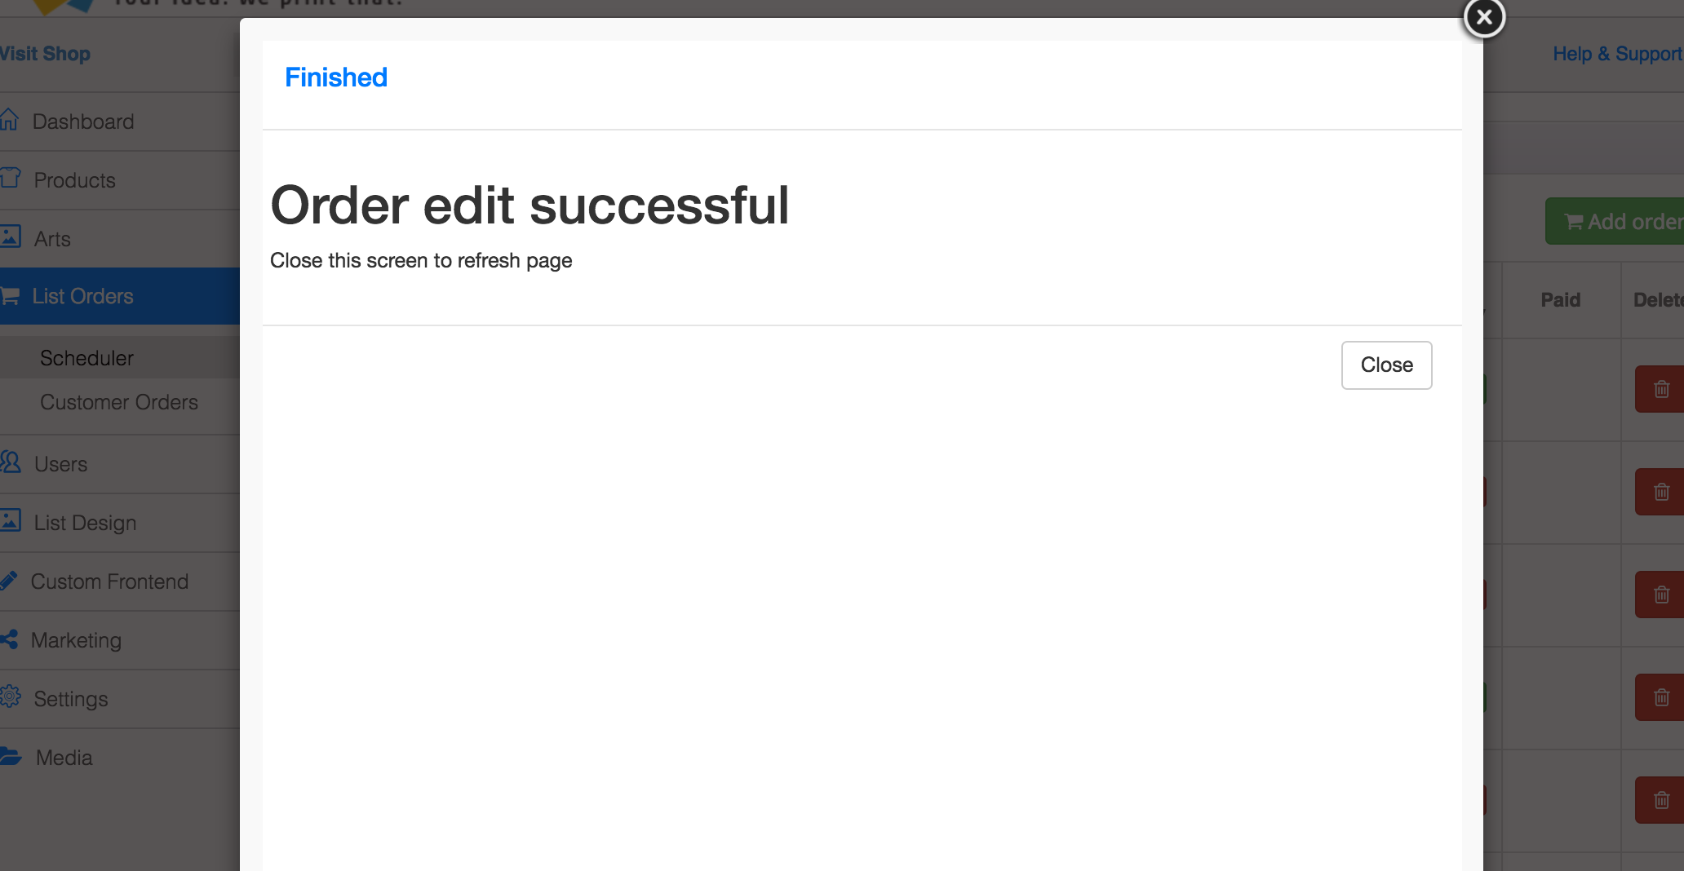

APPAREL GARMENTS

Able to edit garment apparel list

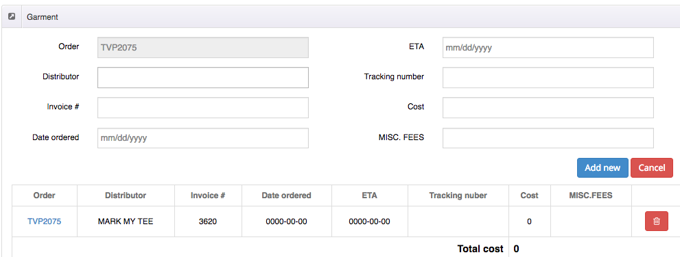

SCHEDULE

Highlighting current jobs that is do THAT day, PAST due, COMPLETED, and due tomorrow. SYMBOLS and different colors

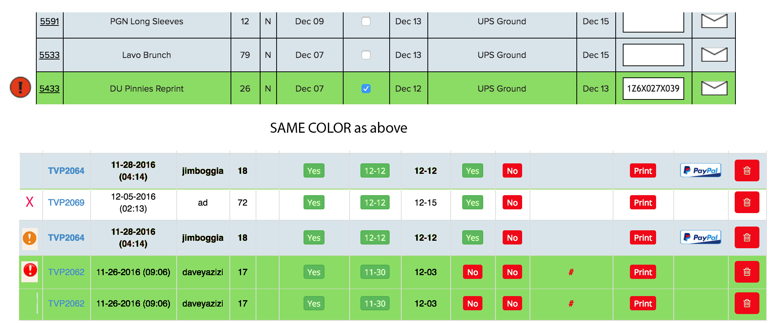

Current jobs **ship** date TODAY: is in with Red “!”

Completed jobs high lighted in green (complted by tracking number)

Jobs that was completed yesterday STAY GREEN NO “!”

Jobs due Tomorrow is Yellow “!”

Jobs Ship date yesterday but not completed RED “X”

CREATING PROOF ON BACK END or having option of ADDING proof.

Editing Manually deposit

This should be the layout:

PAID ONLINE MANUALLY

SHIPPING METHOD 10 10

(-show due date with day)

DISCOUNT 30 30

TOTAL 300 300

PAYMENT METHOD 300 0

DEPOSIT 0 150 (HOW)

BALANCE 0 150

When entering Deposit, show option of CHECK, CASH, OR CREDIT.

If credit is selected open virtual terminal or checkout.